
Koneru Lakshmaiah Education Foundation
(Deemed to be University estd. u/s. 3 of the UGC Act, 1956)
Off-Campus: Bachupally-Gandimaisamma Road, Bowrampet, Hyderabad, Telangana - 500 043. Phone No: 7815926816, www.klh.edu.in

STUDENT CASE STUDY EXECUTION REPORT
Department | FED
Subject | DSA-2
Academic Year | 1-111 Semester | 2025-26
Faculty Name | Mohd. Razia Alangir Banu
Student Name | M. Shravya
Roll Number | 2520030588
Branch | CSE
Course Outcome | CO 4
Case Study Topic: All-Course Reachability Analysis using Floyd-Warshall Algorithm
Work Done Summary:
In this case study, we implemented the Floyd-Warshall Algorithm to analyze reachability and shortest learning paths between all courses in the Skill Bridge – Online Skill Development & Certification Platform. Courses were represented as graph vertices, while prerequisite relationships and learning transitions were represented as weighted edges. The algorithm computed the shortest path between every pair of courses, enabling efficient learning path recommendations.

Implementation Details:

1 Represented courses as graph vertices.
2 Modeled prerequisite relationships as weighted edges.
3 Implemented Floyd-Warshall Algorithm using an adjacency matrix.
4 Computed shortest paths between every pair of courses.
5 Identified reachable and unreachable course combinations.
6 Generated optimized learning paths for students.
. 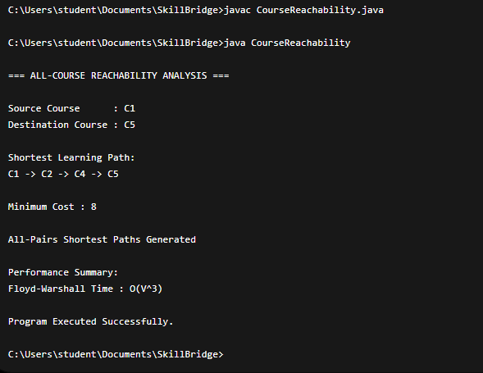

Result: Screenshots / Output

Time Complexity:
Operation | Complexity
Floyd-Warshall Computation | O(V³)
Reachability Check | O(1)
Path Retrieval | O(V)
Matrix Initialization | O(V²)
Where:
- V = Number of courses

Result
The Floyd-Warshall Algorithm successfully computed the shortest learning paths between every pair of courses in the Skill Bridge platform. The system efficiently analyzed course reachability, identified optimal learning sequences, and supported personalized course recommendation systems for students.

GitHub Link:
Student Signature Faculty Signature

